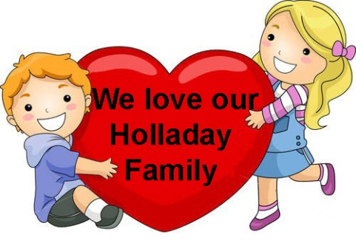
Holladay Family Reunion Treasure Hunt
Name ____________________________

Clue 1 Find family names and all the fun
things we’ll do at our reunion:
N | L | Y | R | D | B | N | S | W | H | Q | C | C | C | N | ARMSTRONG  AUNTS  BASKETBALL  BROTHERS  COUSINS  DADDY  DANCE  FOOD  FUN  GRANDMA  GRANDPA  HIKE  HOLLADAY  HUGS  JOHNSON  JOKES  MOM  NEWBY  NOBLE  PICNIC  SINGING  SISTERS  SKITS  SMILES  SWIMMING  UNCLES  VOLLEYBALL  WINSTON
O | A | D | A | A | O | A | Q | R | D | I | H | Z | I | O
B | W | N | V | S | K | N | S | N | E | O | K | N | N | T
L | C | T | N | H | U | G | S | K | L | H | U | E | C | S
E | E | H | I | B | V | J | D | L | E | S | T | X | I | N
V | O | L | L | E | Y | B | A | L | L | T | E | O | P | I
J | N | V | A | H | F | D | R | A | S | Y | B | K | R | W
C | F | E | C | I | A | O | M | E | P | D | U | A | O | B
S | O | F | W | Y | S | S | S | S | L | D | M | Z | L | J
I | O | U | F | B | E | F | T | X | S | A | N | W | Z | L
S | D | U | S | L | Y | N | R | S | C | D | E | A | U | F
T | N | I | I | I | U | Z | O | A | M | D | N | A | R | G
E | L | M | K | A | N | G | N | I | M | M | I | W | S | G
R | S | T | I | K | S | S | G | U | N | C | L | E | S | H
S | I | N | G | I | N | G | M | O | M | L | B | P | Q | X

Clue 2 How many letter S did you find? ___________________

Clue 3 Answers to the riddles: 1.__________________________ 2. _____________________

3. _______________ 4.___________________________ 5. _____________________

Clue 4 How many people in the picture on the website? ______________

Clue 5 What nice things did you tell the five people you hugged?________________________

____________________________________________________________________________

____________________________________________________________________________

____________________________________________________________________________

